**FINWOOD HILL FARM SHOP**

**Free-range Gloucester Old Spot Pork**

**Pedigree produce from pedigree pigs**

**Born and reared outside**

**Contact Ann : 07899 923075** [**Finwood.dexter@hotmail.co.uk**](mailto:Finwood.dexter@hotmail.co.uk)

**Mill Lane Lowsonford B95 5HH Open Friday and Saturday 11am -5pm**

**GLOUCESTER OLD SPOT PORK**

**Rolled leg joint £12.00/kg**

**Rolled shoulder joint £ 12 .00/kg**

**Boneless loin joint £16.00/kg**

**Loin steaks £16.00/kg**

**Leg steaks £12.00/kg**

**Pork fillet £16.00/kg**

**Belly joint £10.50/kg**

**Drycure Back Bacon £19.00/kg**

**Drycure Streaky Bacon £16.00/kg**

**Rolled Gammon Joint £13.00/kg**

**Pork sausages £8.99/kg**

**Minced Pork £10.50/kg**

**Sausage Meat £9.50/kg**

**Diced pork £12.00/kg**

**Rack ribs £5.00/kg**

**JOINTS available in approx 1-1.5 kilo sizes.**

**Larger sizes by advance order.**

**SAUSAGES BY WEIGHT (min 6 in a pack)**

(£3.25 - £4.50 per pack )

**BACON BY WEIGHT (4/6 slices in pack) (Approx. £3/4.00 per pack)**

**Minced, Diced and Sausagemeat in approximately 450-500g packs**

PORK RIBS FOR THE BBQ.

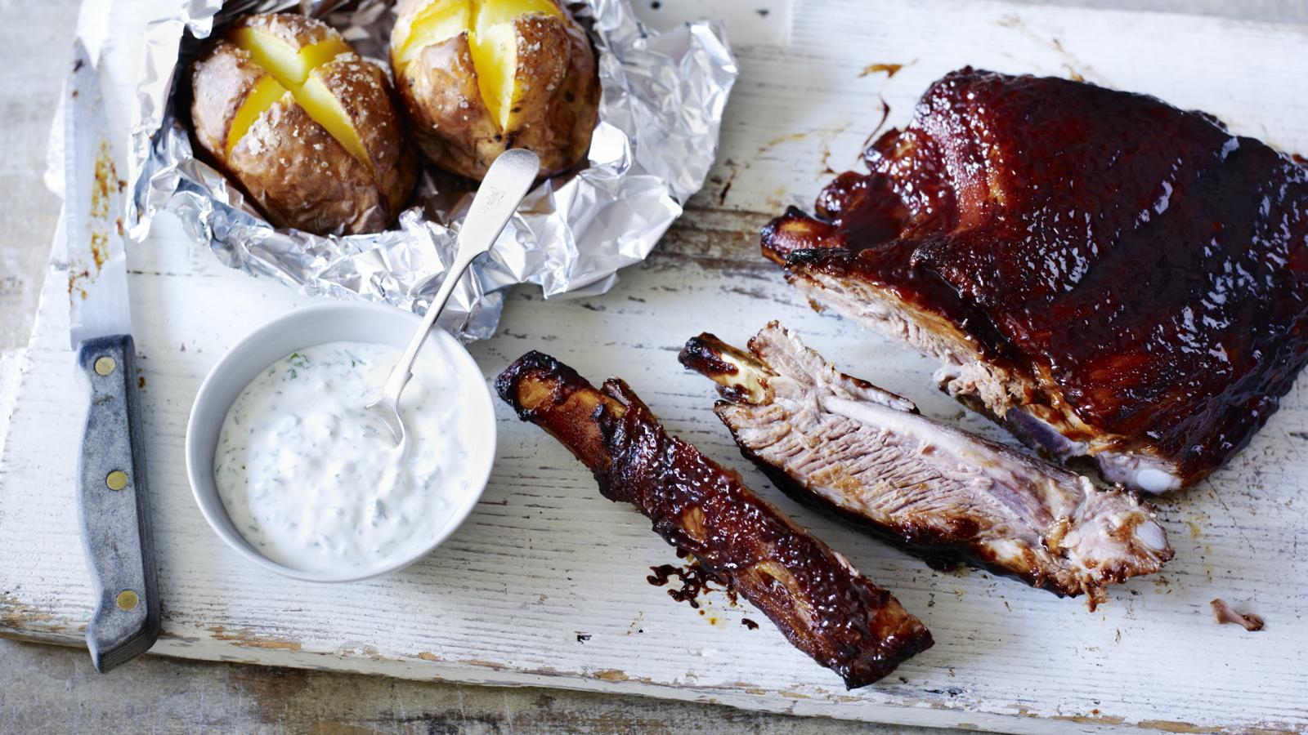

SEE PORK RECIPES PAGE FOR A SELECTION OF DELICIOUS IDEAS.

Sent from my iPad